

3

BOTTOM PLOW
OWNERS MANUAL

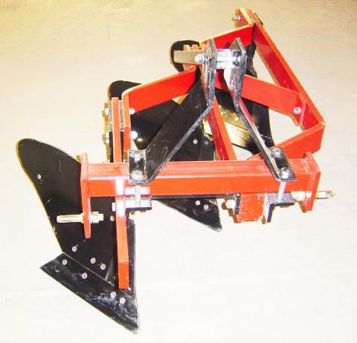

MOLDBOARD PLOWS

To The Owner:
Read this manual before using your moldboard plow. The information presented will prepare you to do a safer, better job. Study this manual and become acquainted with all adjustments before attempting to operate your new implement.

This moldboard plow has been carefully manufactured to provide dependable and satisfactory use.

Observe all safety information in this manual.

WARNING
Be sure that the tractor’s front end is weighted to maintain stability. Tractor front end weight should be at least 20% of the total tractor weight with the equipment in the raised position.

WARNING
To avoid tire damage always check the tire clearance immediately after making top link, and / or wheel spacing adjustments.

WARNING
The plow is equipped with shearbolt protection. Replace the shearbolt with a grade 2 bolt only. Use of a stronger bolt will void the warranty and may damage the plow.

SAFETY SUGGESTIONS:
- Read and understand the owner’s manual for both the tractor and the implement.
- Do not walk on the implement.
- Do not adjust implement while it is in motion.
- Keep all bolts tight, and all nuts in place.
- Do not work on or under the implement.
- Do not stand between implement and tractor.
- Keep implement in good operating condition.
- Operate all controls from tractor seat.
- Only the operator should be allowed on the tractor during operation.
- Use front weights according to your tractor manual to provide front end stability.
- Always lower the implement to the ground when not in use.
- Use extreme care when transporting implement particularly over rough ground, ditches, or slopes.
- Do not transport over 10 miles per hour.
- Before performing any maintenance or inspecting an implement, lower to the ground, turn off tractor engine and block as required.

Plow Assembly Instructions

Plows are shipped with the 3-point hitch in the down position to save on shipping costs. Before you can use the plow, it must be assembled in the upright position. The instructions for doing so are as follows:

- Remove the metal banding that is securing the Cross Shaft Assembly ( P-81 ) to the bottom of the frame. Set the Cross Shaft Assembly ( P-81 ) aside temporarily.
- Remove the 5/8” nut from the back of the Rear Strut ( P-84 ), but do not remove the bolt.
- Remove the four 5/8” x 5 1/2" bolts from the Front Struts ( P-79 & P-80 ). Then lay these parts aside temporarily.
- Reposition the Cross Shaft Assembly ( P-81 ) on top of the Hitch Brace Assembly ( P-82 ) and the Angle ( P-83 ) with the Link Pins ( MB-6 ) hanging down.
- Reposition the Front & Rear Strut Assembly on top of the Cross Shaft Assembly.
- Reinstall the four 5/8” x 5 1/2" bolts and the nut for the Rear Strut. Re-tighten all fasteners beginning with the Rear Strut.
- Remove the Category I Link Pins and turn them around and re-tighten them. The plow is now ready to use.

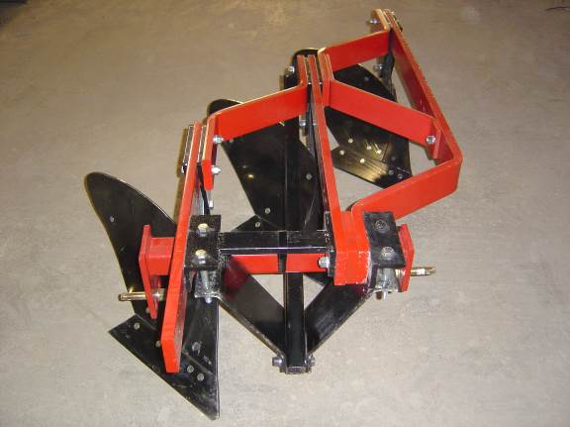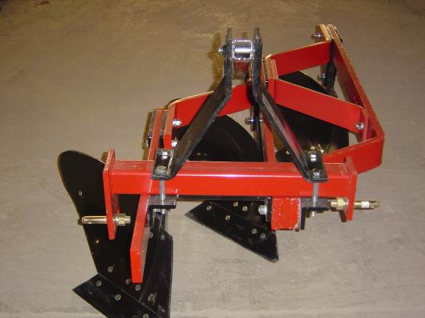

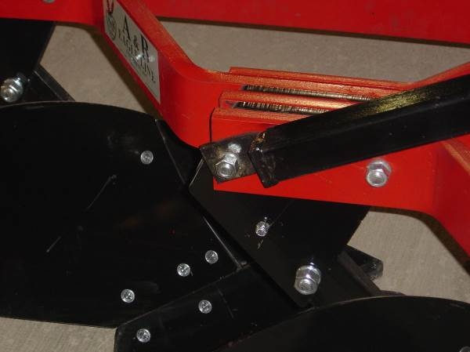

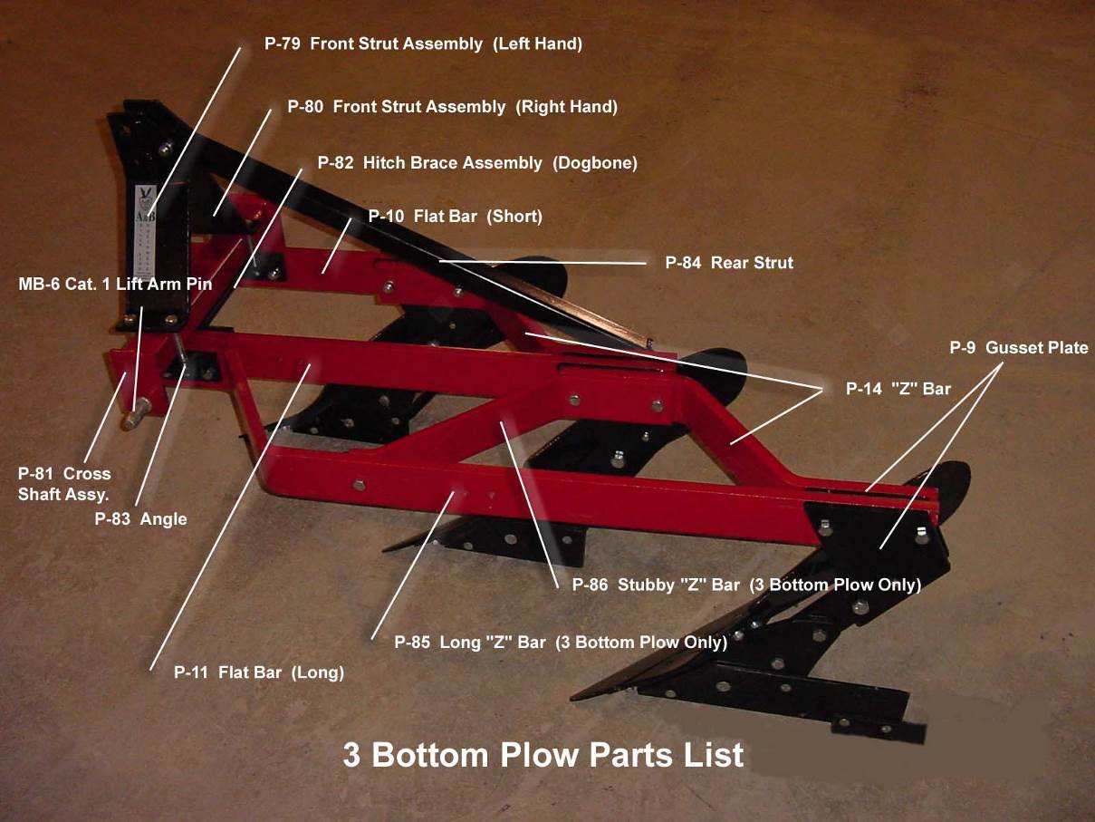

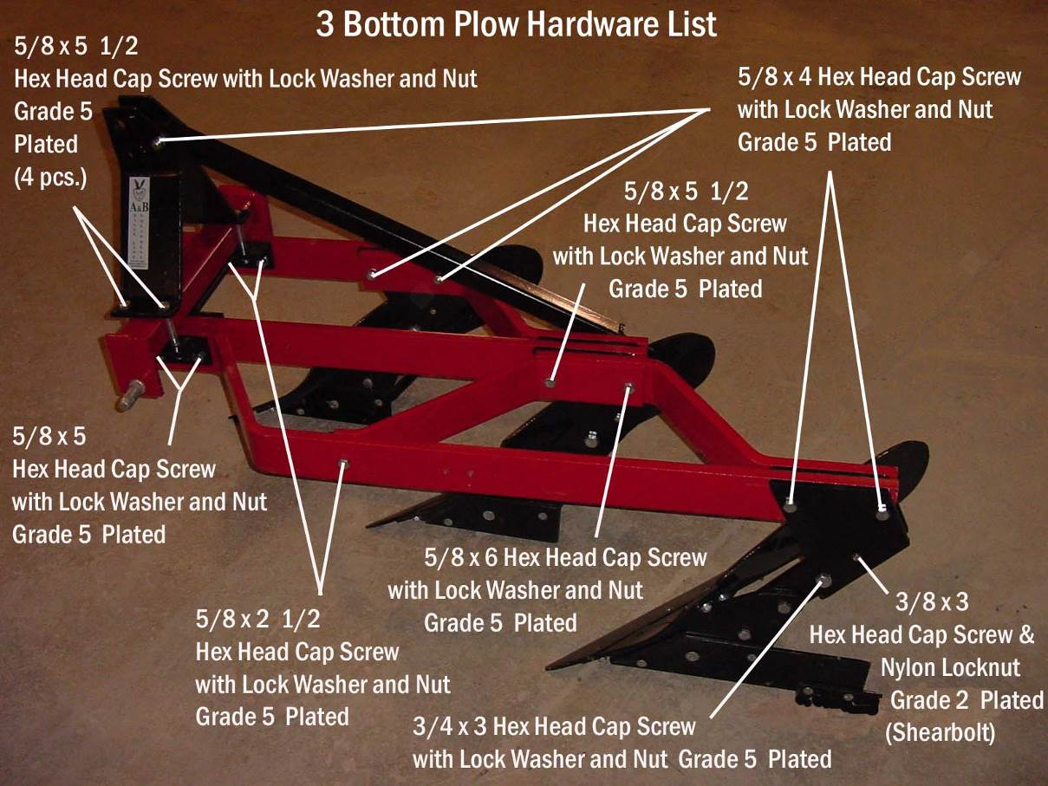

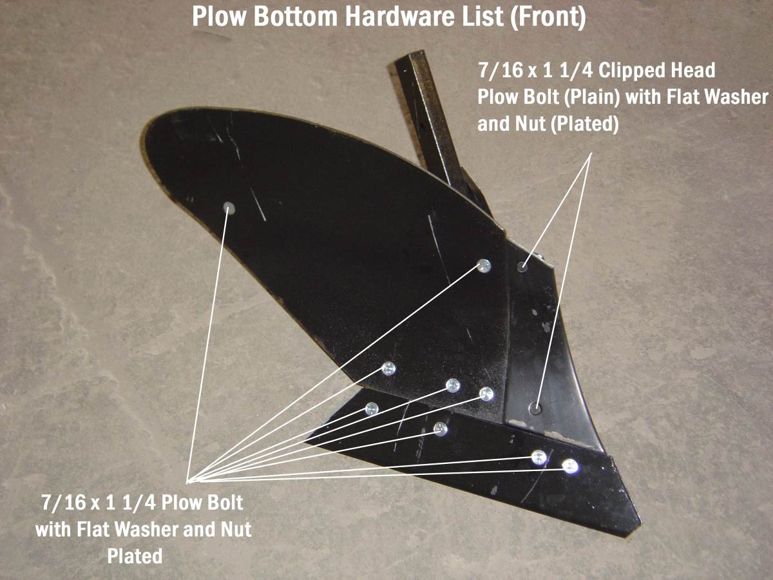

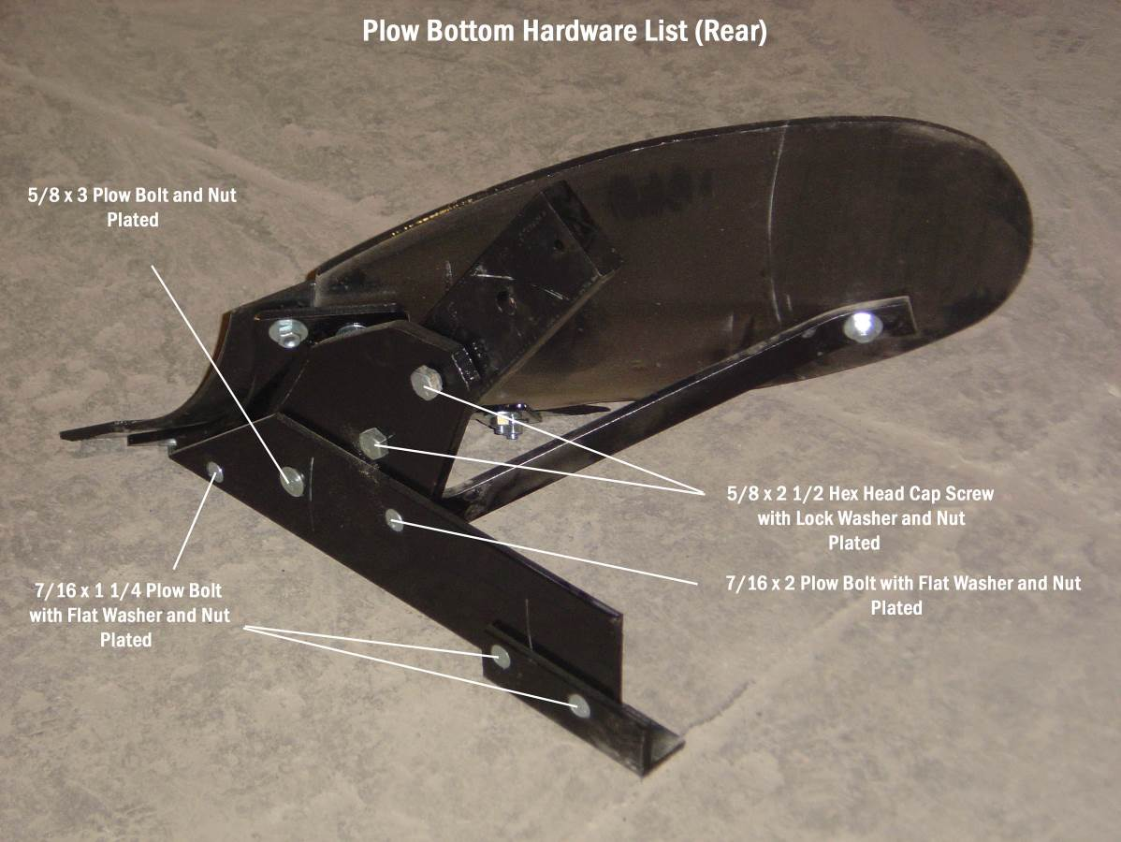

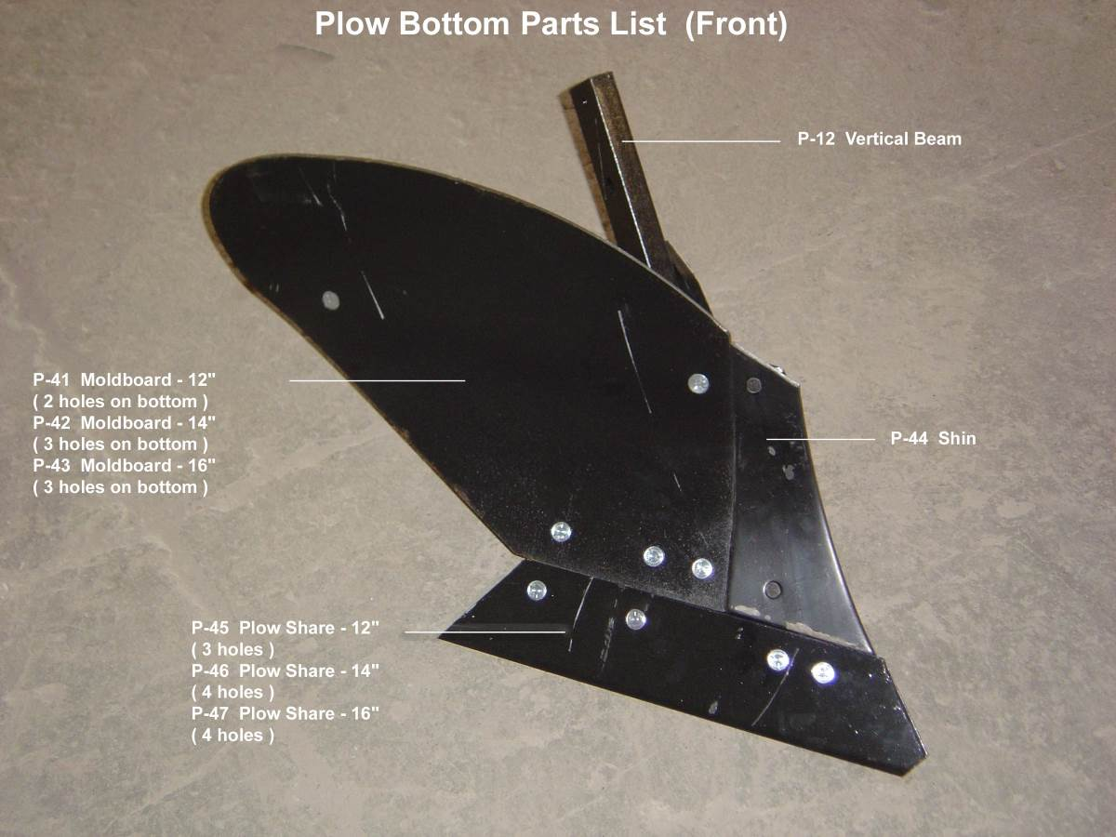

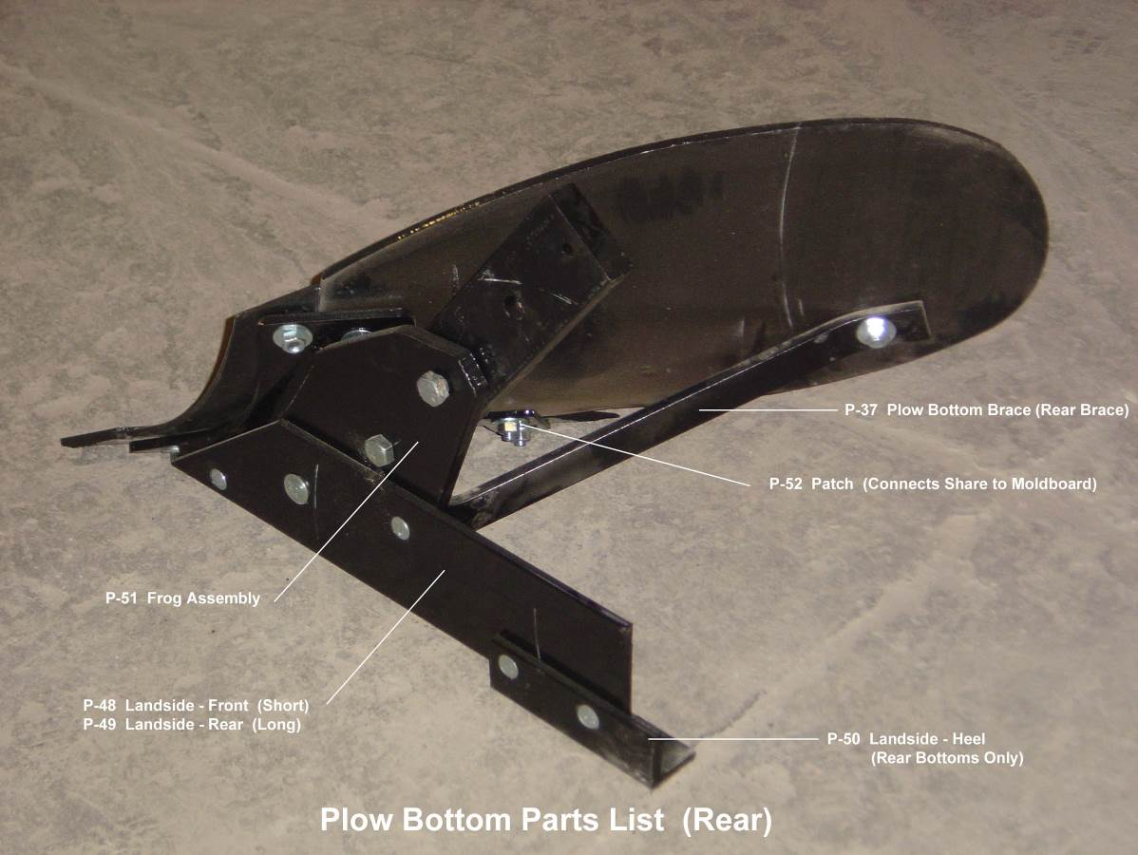

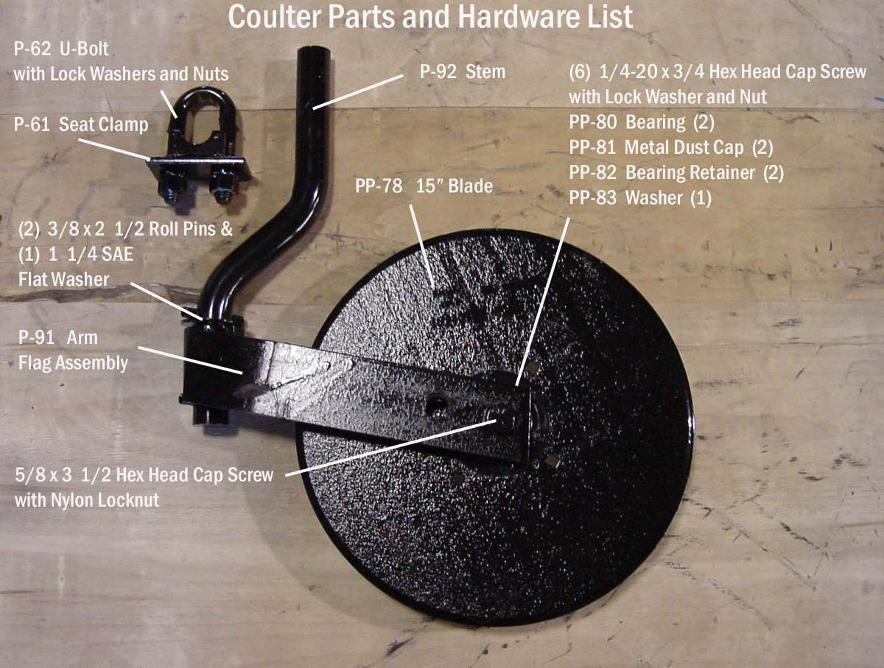

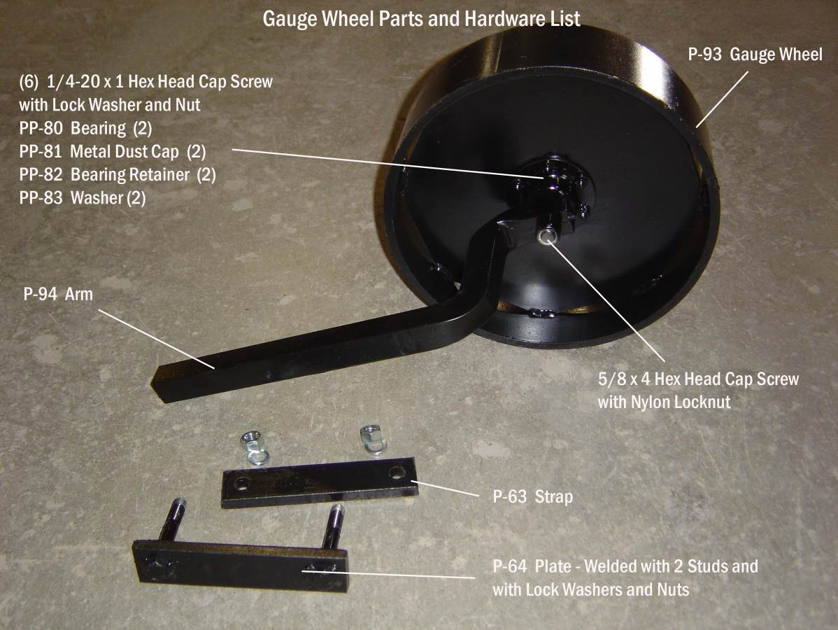

Plow Coulter
NOTE: Rolling coulters should be used on plows at all times. With disc coulters correctly set, plowing will be smoother and neater. Plows will pull easier.

The rolling coulter disc outlines the cut of the plow bottom. It cuts through sod, surface trash, aids in securing clean, uniform furrows, reduces draft and lessens wear on the cutting edge of the plow bottom.

Coulter Mounting
Mount the coulter stem on the plow frame using the “U”-bolt and welded stem seat as shown on the following page. Tighten only until snug.

Coulter Adjustment
To adjust the coulter, twist the stem to get the lateral adjustment, and raise or lower it to get the proper height.

The rolling coulter should only be positioned far enough to the left of the landside to allow a clean, straight furrow wall. For average conditions set the coulter blade between a 1/2 inch and 5/8 inch to the left of the landside. Loose ground and tough scouring conditions will sometimes require the coulter to be set a little wider.

The rolling coulter should be set deep enough to cut trash and leave a clean furrow wall. It should not be run too deep or it will push trash instead of cutting it. Under all conditions, try to maintain a greater distance between the top of the shin and the rear of the coulter blade and a lesser distance between the bottom of the coulter blade and the shin.

In hard ground conditions raise the coulter to reduce the tendency toward riding the plow out of the ground. In light and loose soils, especially when there is heavy or rough trash, move the coulter down. Tighten “U” bolts when adjustments are completed.

Note: Coulter blades must be kept sharp.

Moving the right lift arm pin forward or backward changes width of cut. Moving the lift arm pin forward will decrease the width of cut, and moving it backward will increase the width of cut.

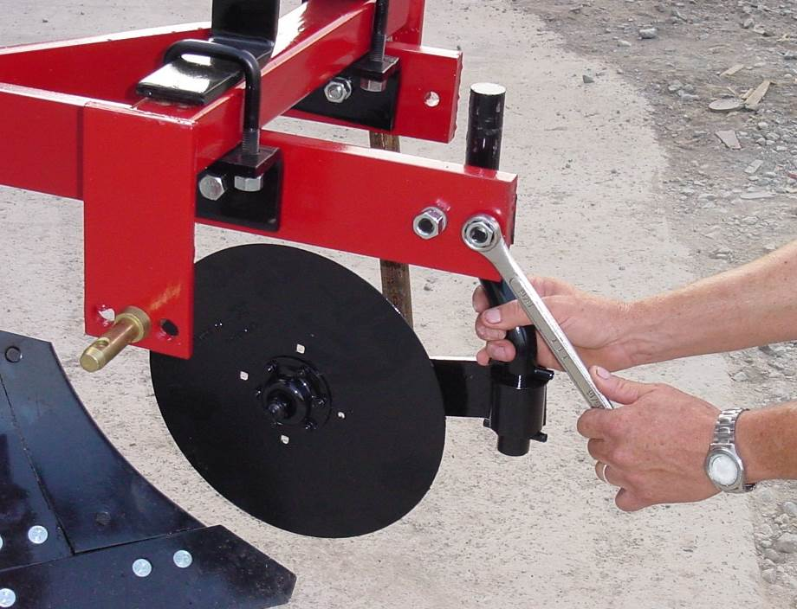

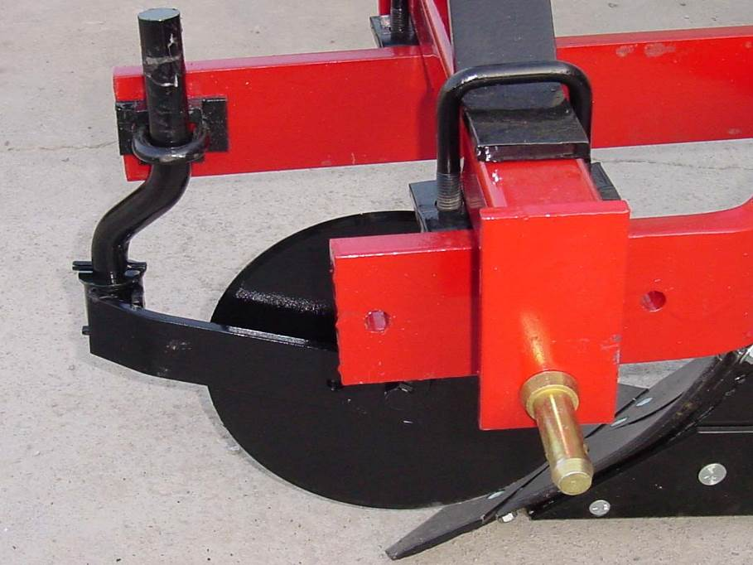

Gauge Wheel
The gauge wheel is shipped assembled and has only to be bolted to the main beam using the clamp assembly with lock washers and nuts provided as shown in the picture below.

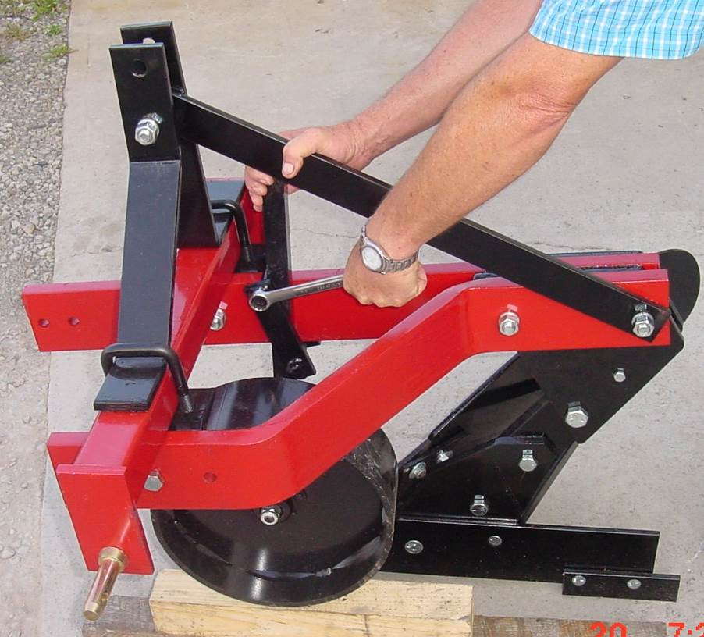

NOTE: For additional clearance between the coulter and gauge wheel, mount the stem on the other side of the main beam. This is recommended on 2 bottom 12” plows.

Depth adjustment is made by sliding the gauge wheel through its clamp.



LIMITED WARRANTY

A & B Equipment, Inc. warrants its products to be free of defects in material and workmanship for a period of 1 year from the date of purchase, under normal use and service providing the equipment is purchased for individual and not commercial use. Defective parts must be returned to A & B Equipment, Inc. at owner’s expense for inspection. The obligation of A & B Equipment, Inc. under this warranty shall be limited to shipment, to the original purchaser at retail, of the parts of equipment intended to replace the part or parts acknowledged by A & B Equipment, Inc. to be defective in material or workmanship and does not include any installation or transportation costs. No warranty is made with respect to items made by others, since such items are warrantied by their respective makers. No liability is assumed for expenses or damages resulting from the malfunction or interruption in operation of equipment.

This warranty does not apply to any equipment which has been damaged, in any accident, or by fire, flood, act of God, or which has been subjected to abuse, misuse, negligence, alterations, and / or tampering.

Purchaser’s exclusive remedy for breach of warranty, other defect, or conduct giving rise to liability shall be the repair or replacement of the product sold, and the manufacturer under no circumstances shall be liable for economic loss or incidental consequential damages. Effective upon the expiration of this limited warranty ( one year from the date of purchase), the manufacturer disclaims all implied warranties, including the warranty of merchantability and fitness.

A & B Equipment, Inc. reserves the right to make improvements and changes in specifications without notice or obligation to modify previously sold units.

